**Assignment L07 - Chihuahua or Muffin with CNN**

**Team EyeConic**

**Brooke Broderick - W217065417**

**Matthew Choo - W206744145**

**Cameroun White-W216530571**

**Melvis Maduagwu-W216890463**

**Erick Banegas - W2162009**

**NancyChieu-W000098778**

**Yoana Cook - W215913890**

**6252-ITAI-1378-Comp Vision-Artificial Intel-RT-15698 - Spring 2025**

**Professor Anna Devarakonda**

**March 8, 2025**

**Intro:**

* In this lab, we will be doing a CNN (Convolutional Neural Networks) on the Chihuahua or Muffin file. CNN is a type of network that is the “architecture for deep learning that learns directly from data”(Mathworks). It is also useful in finding patterns in images such as objects, classes and categories. This network is effective where it can classify “audio, time-series, and signal data”(Mathworks). It is also a type of mathematical operation called convolution rather than a matrix multiplication. Its architecture consisted of four types of layers such as “convolution, pooling, activation and fully connected” (Run ai).

CNN_1 Chihuahua or Muffin.ipynb Original Code

**Yoana Cook:**

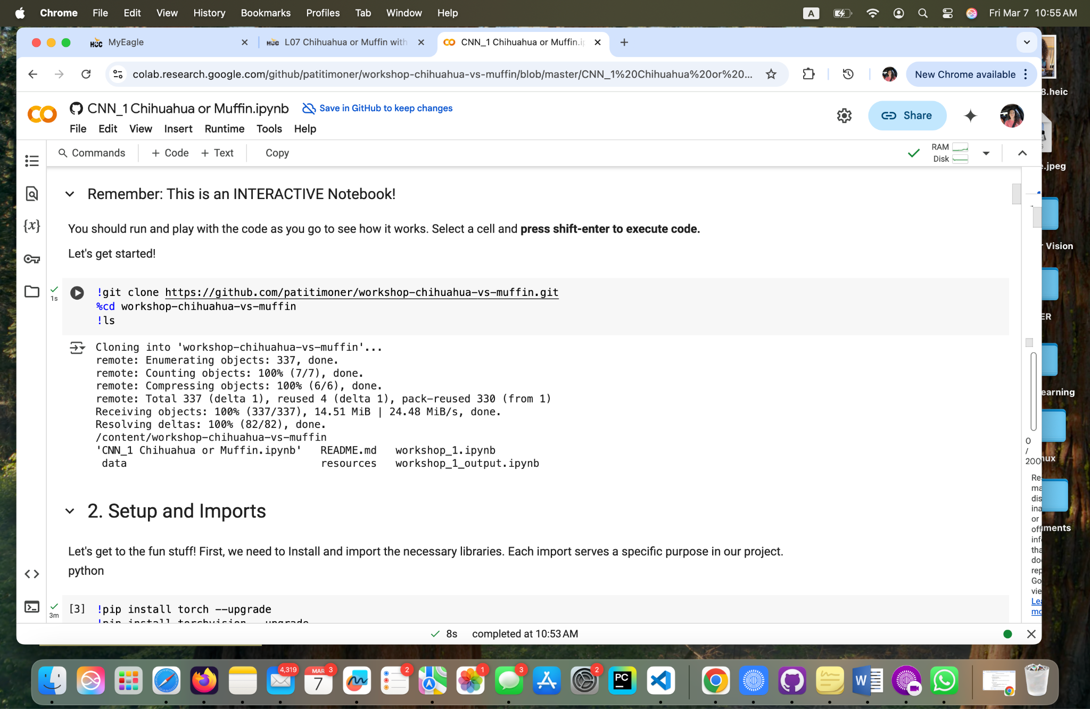

**Fig 1 - Yoana Cook: Mounting the GitHub repository to Google Drive**

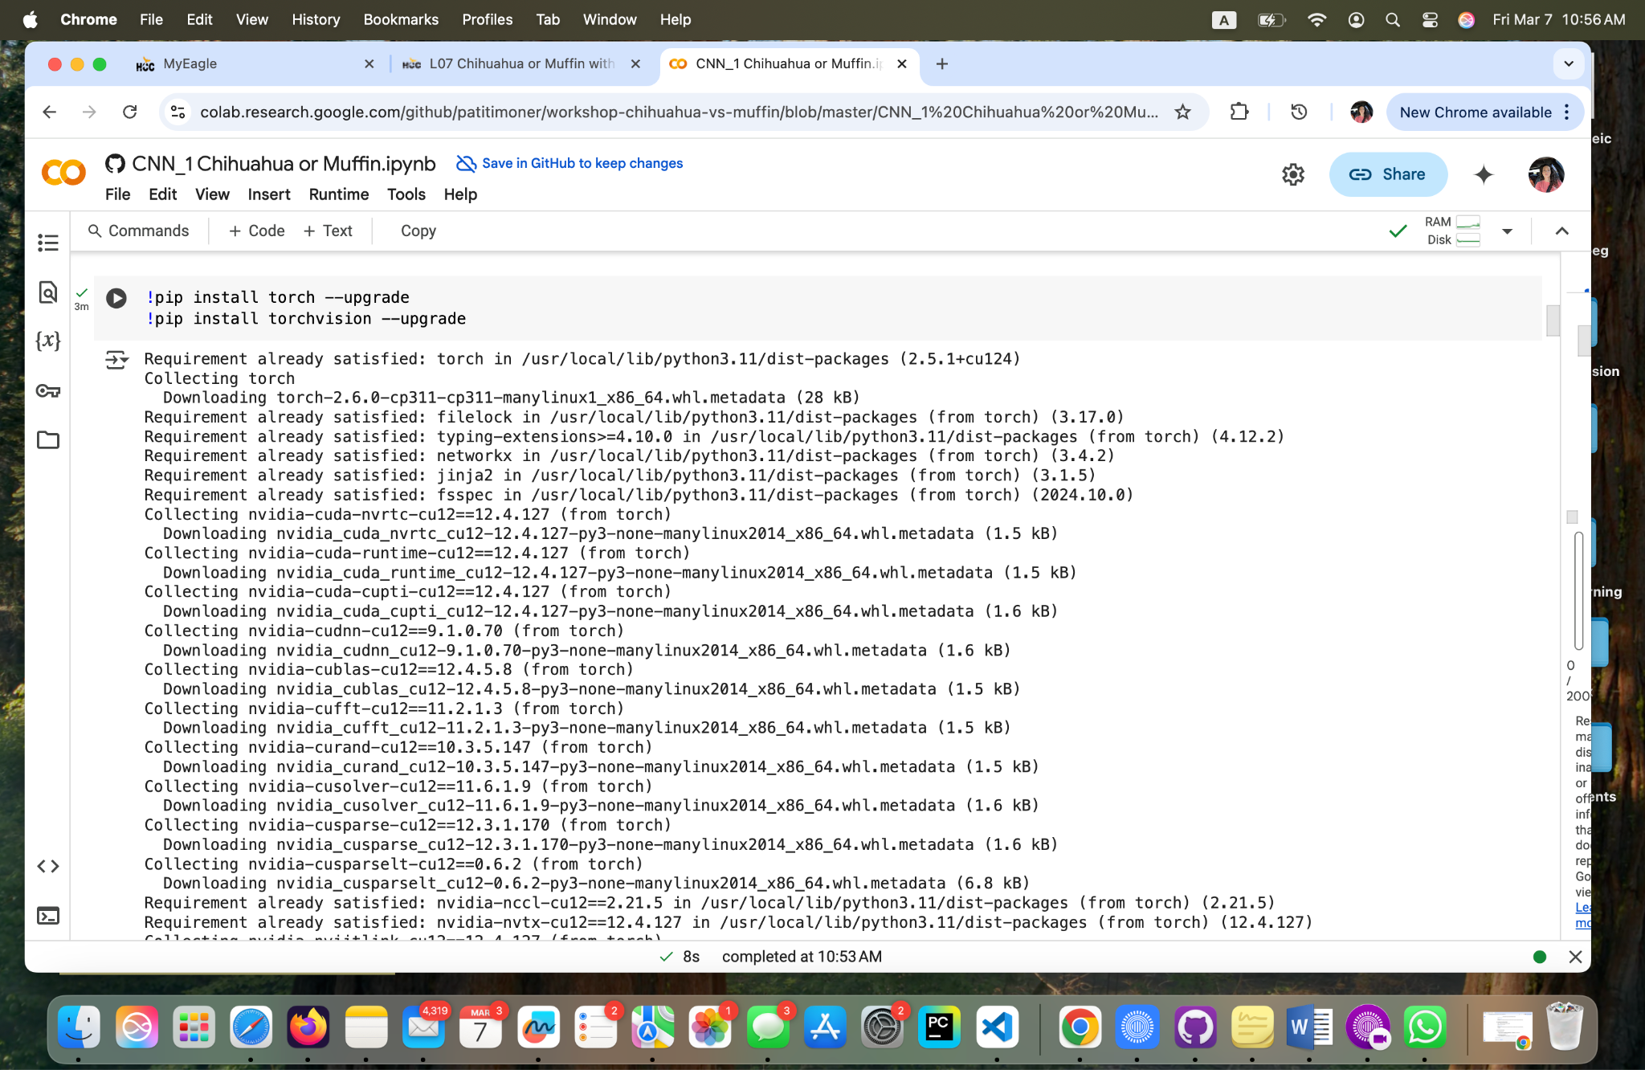

**Fig 2 - Yoana Cook: Installing the necessary libraries.**

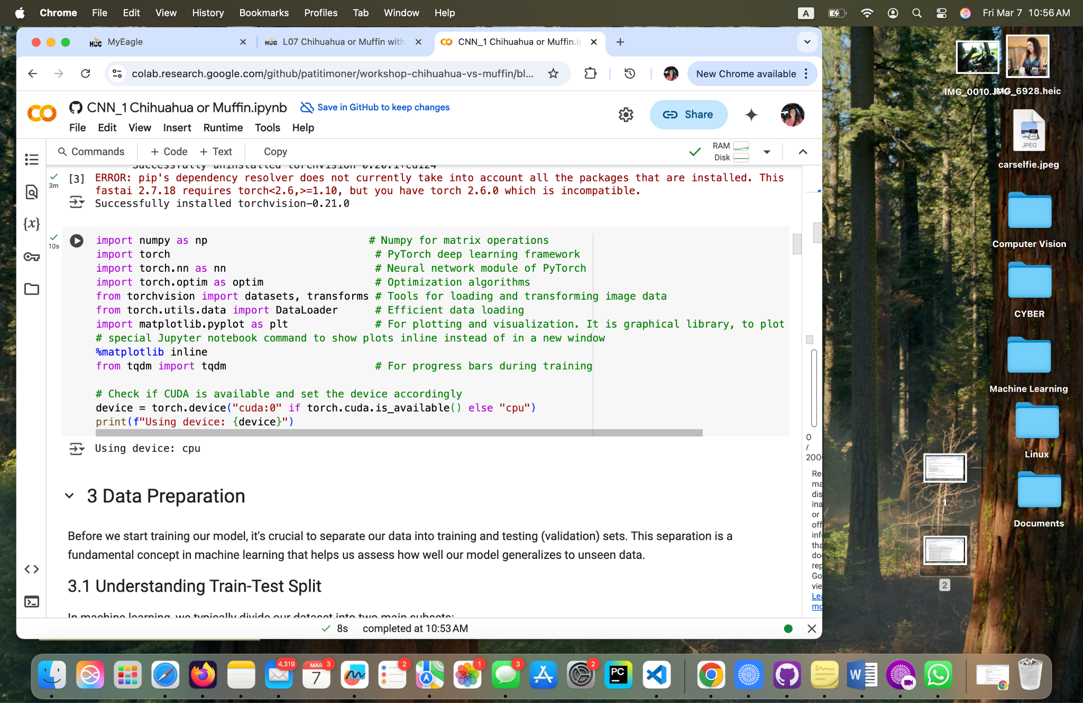

**Fig 3 - Yoana Cook: Importing the necessary libraries.**

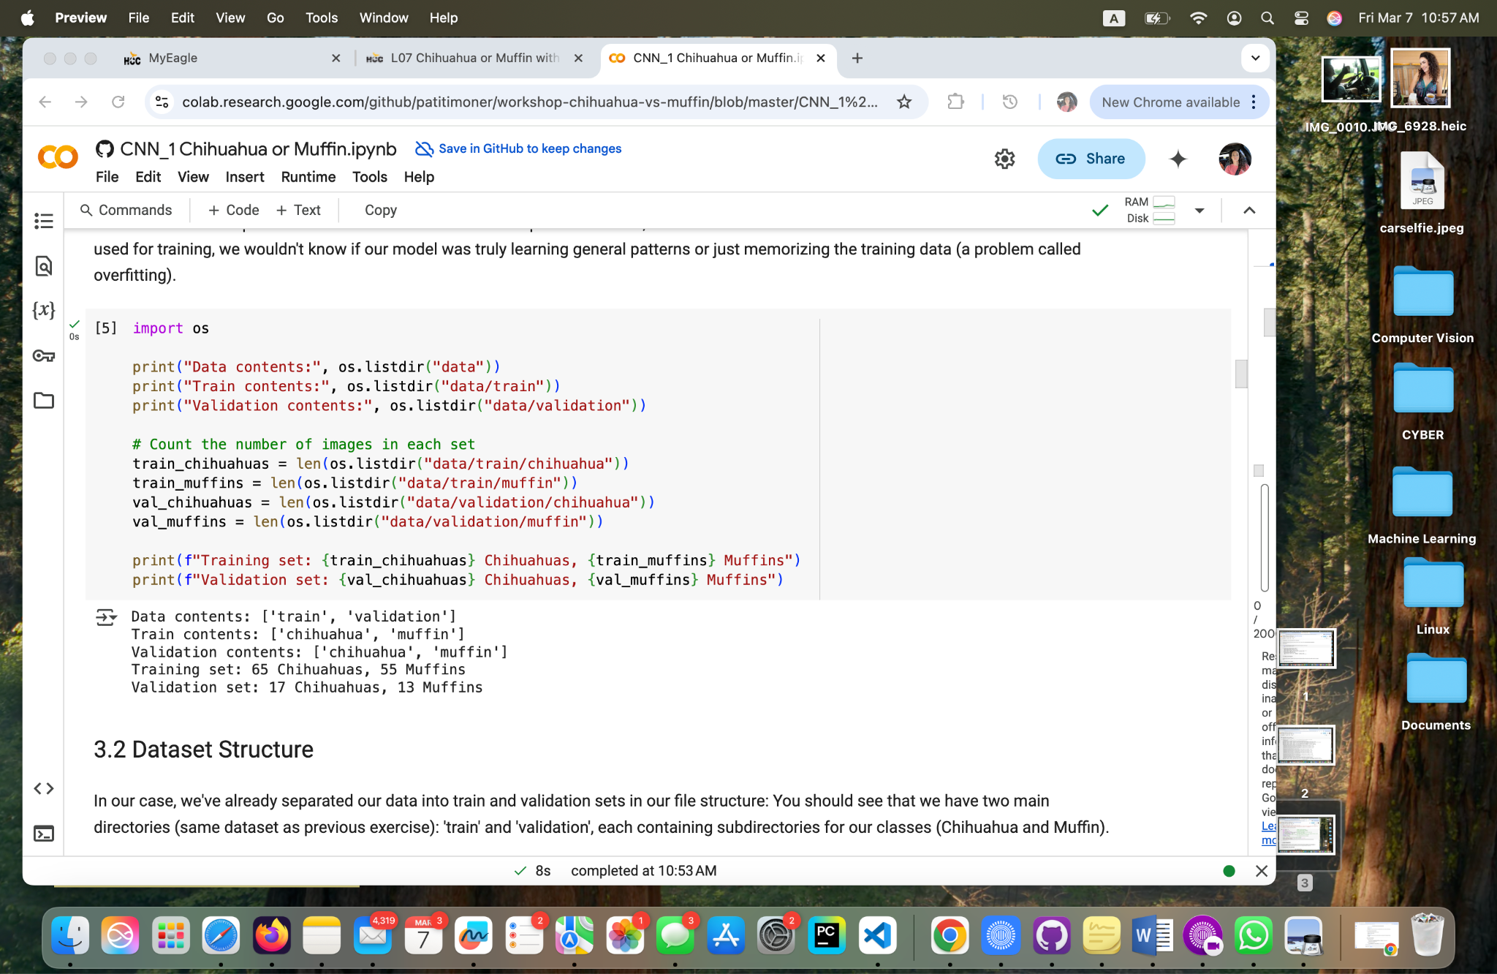

**Fig 3.1 - Yoana Cook: Importing the necessary libraries.**

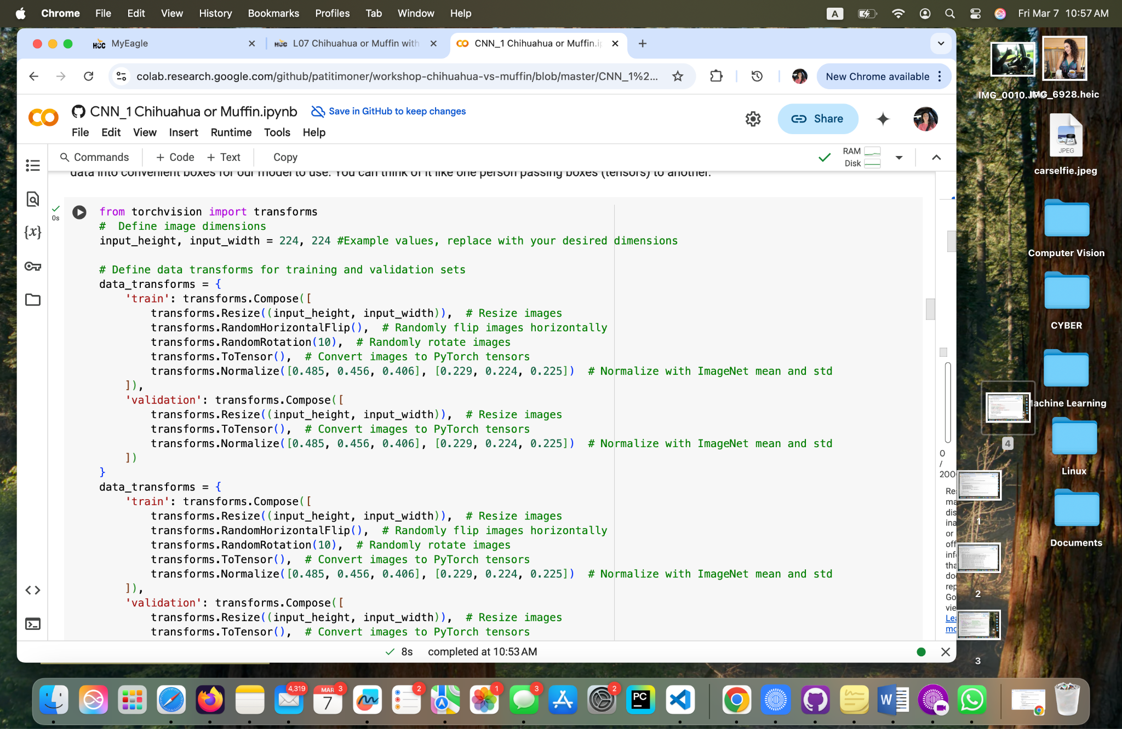

**Fig 4 - Yoana Cook: Training and separating the data.**

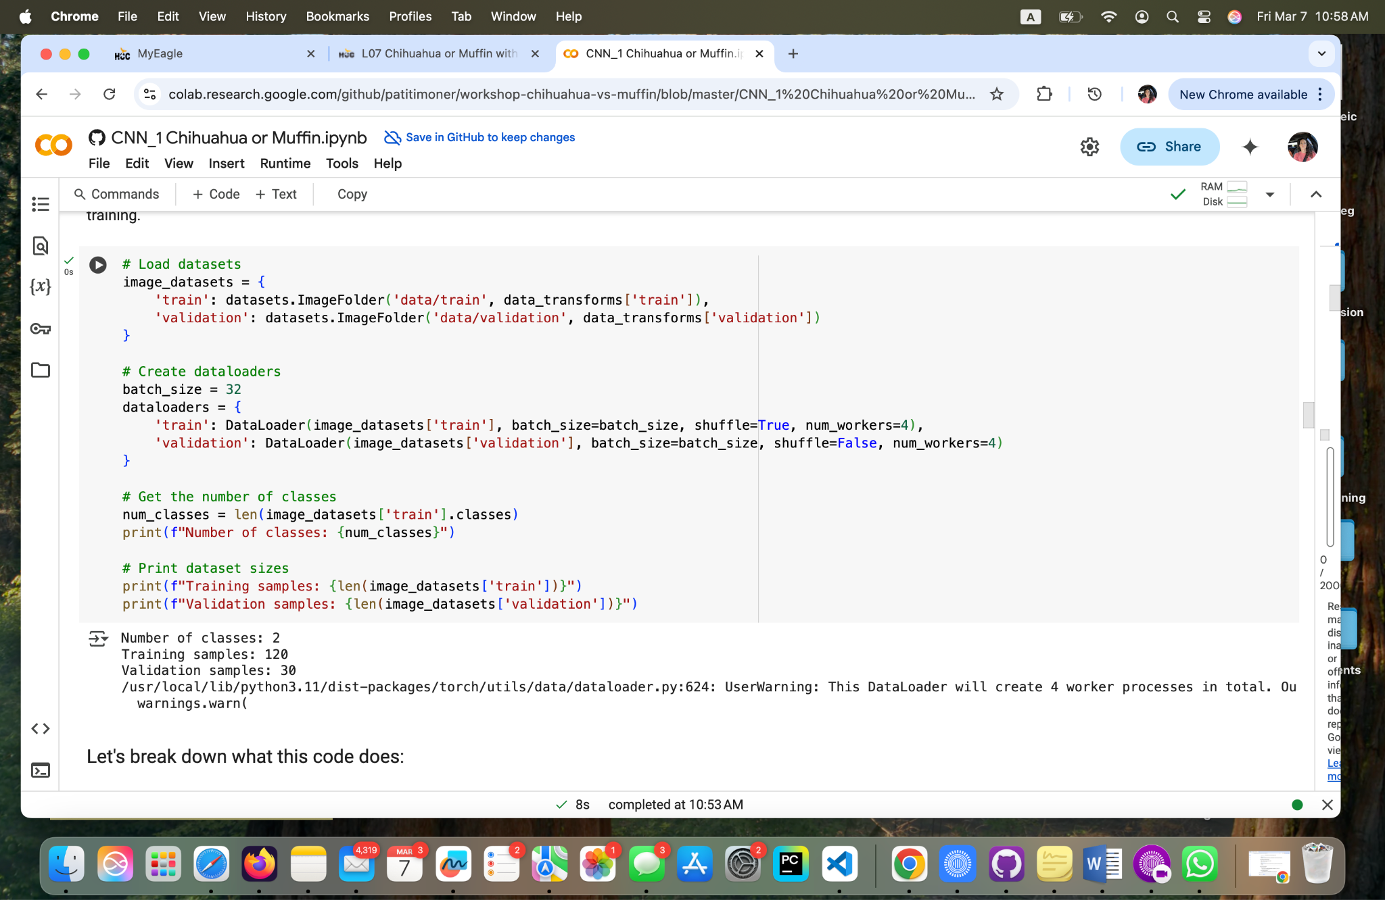

**Fig 5 - Yoana Cook: Creating Dataset and Dataloaders.**

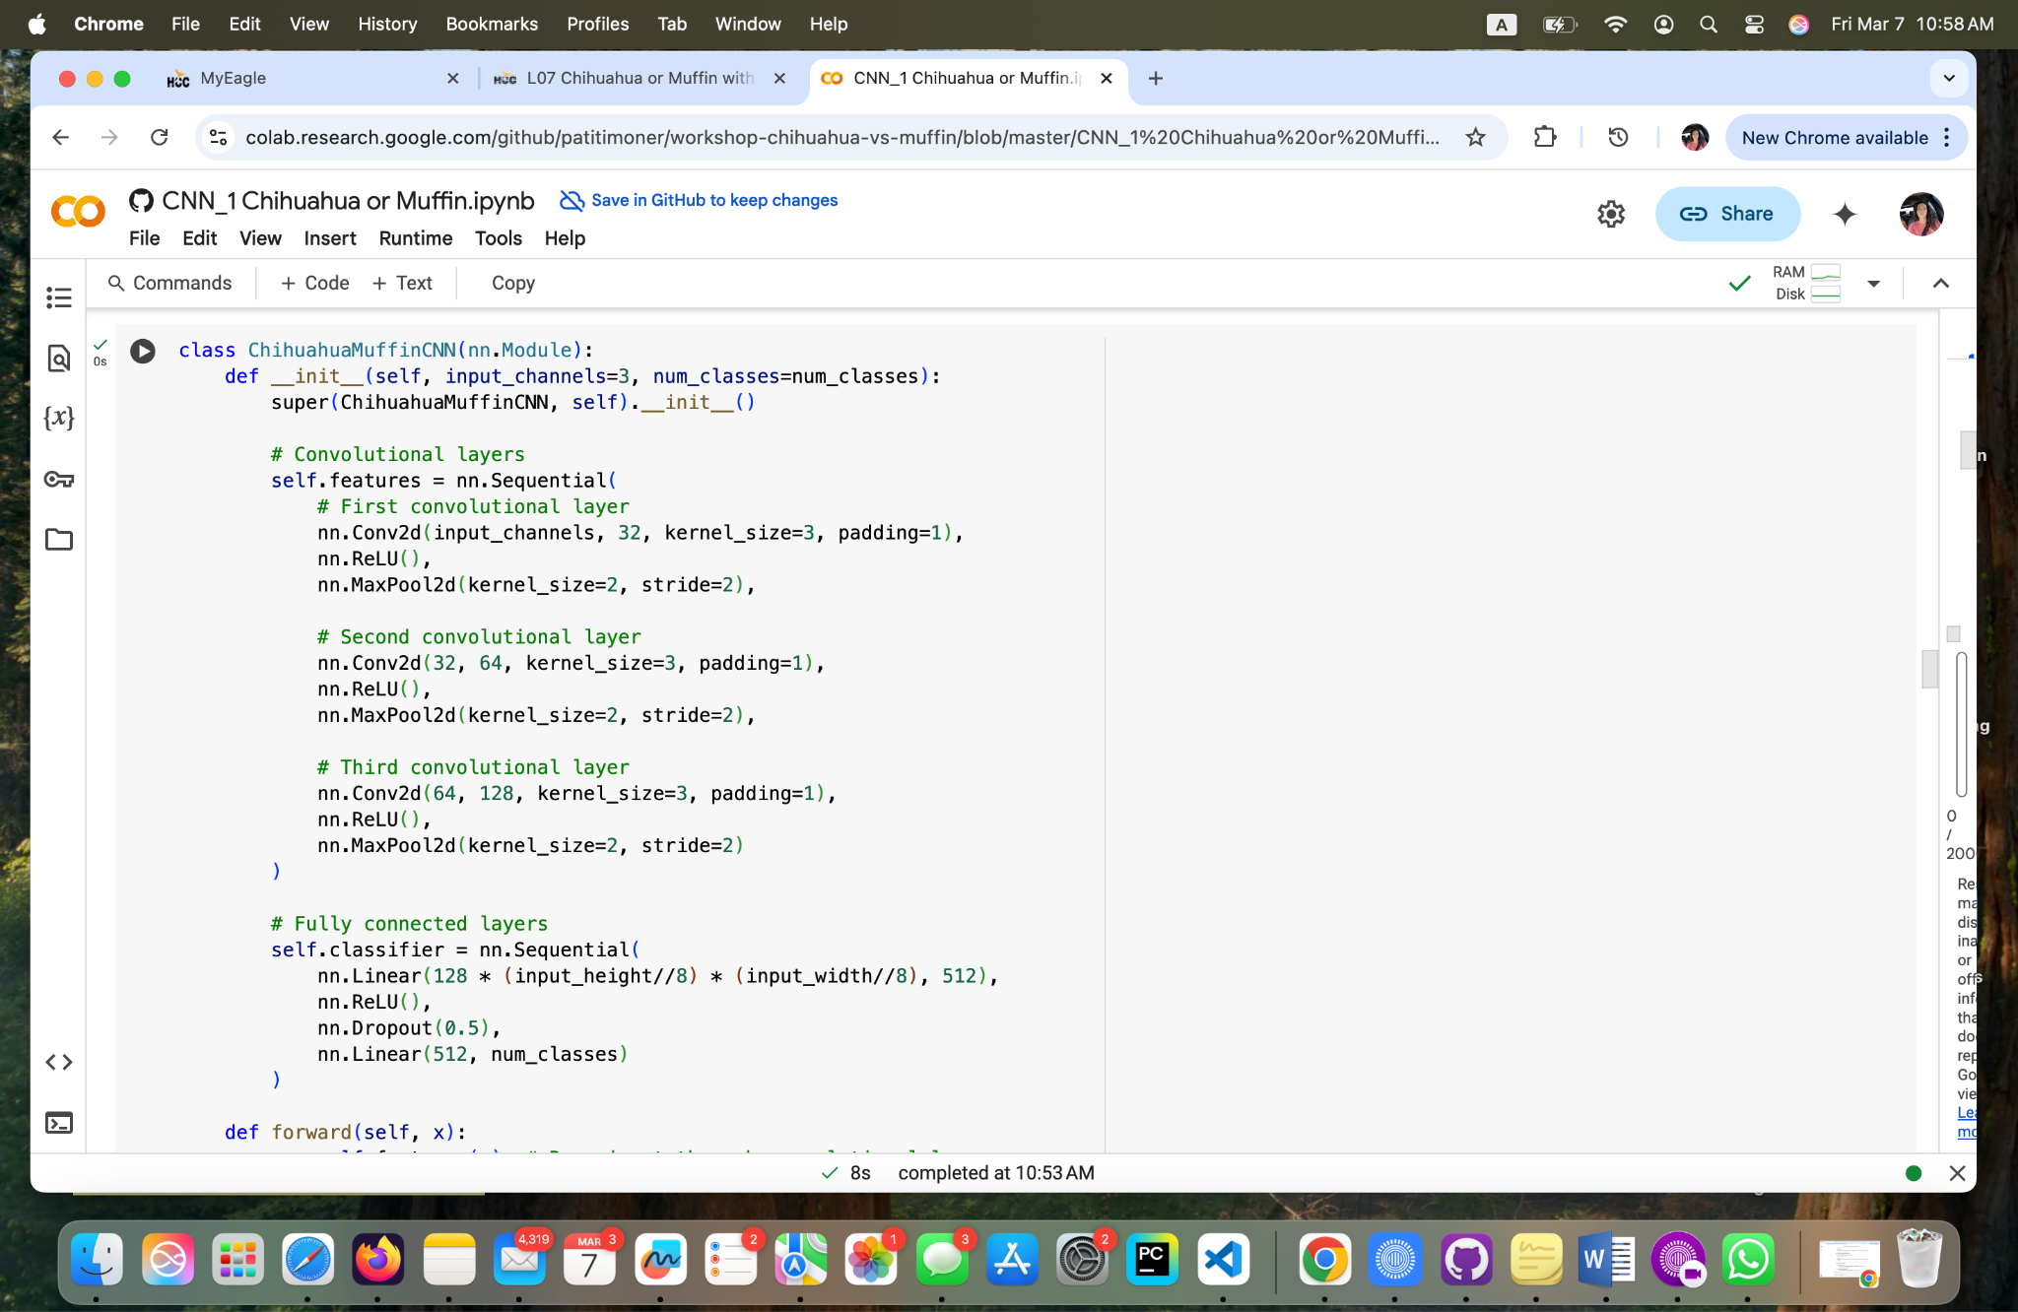

**Fig 6 - Yoana Cook: Defining the CNN model.**

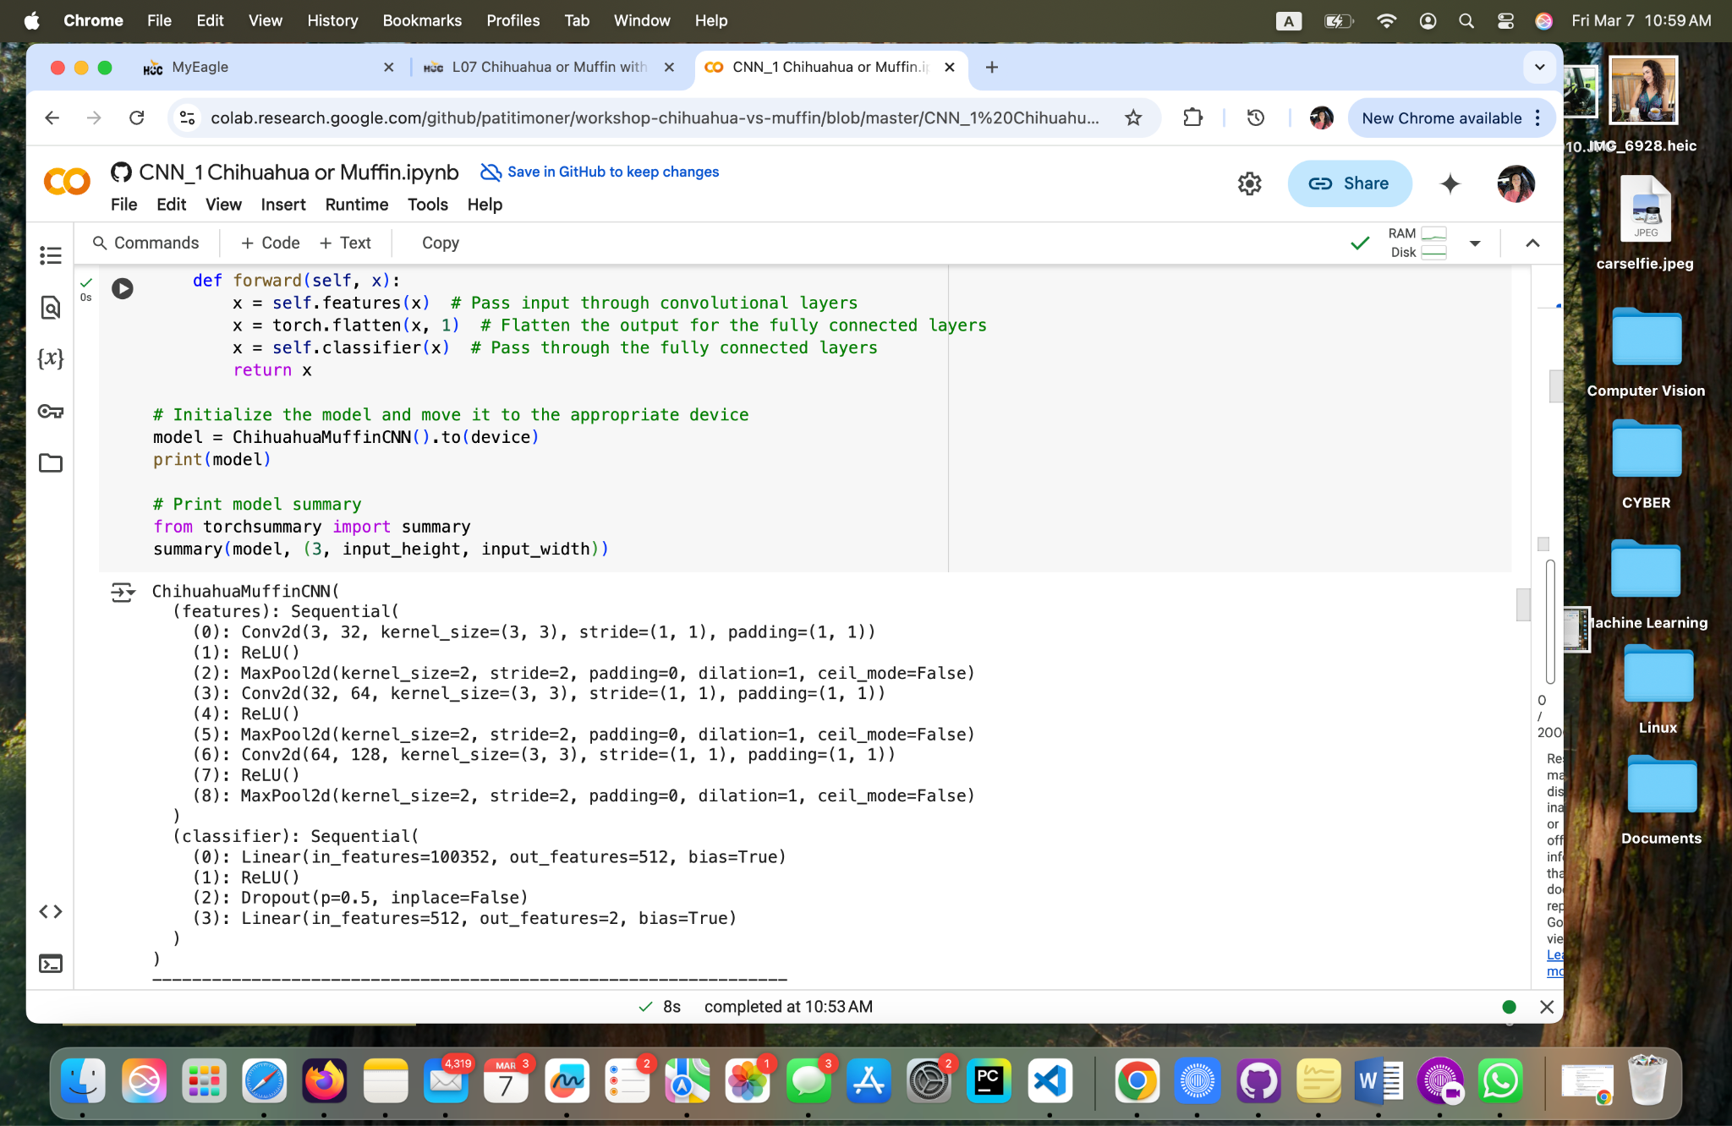

**Fig 7 - Yoana Cook: ChihuahuaMuffin CNN( features)**

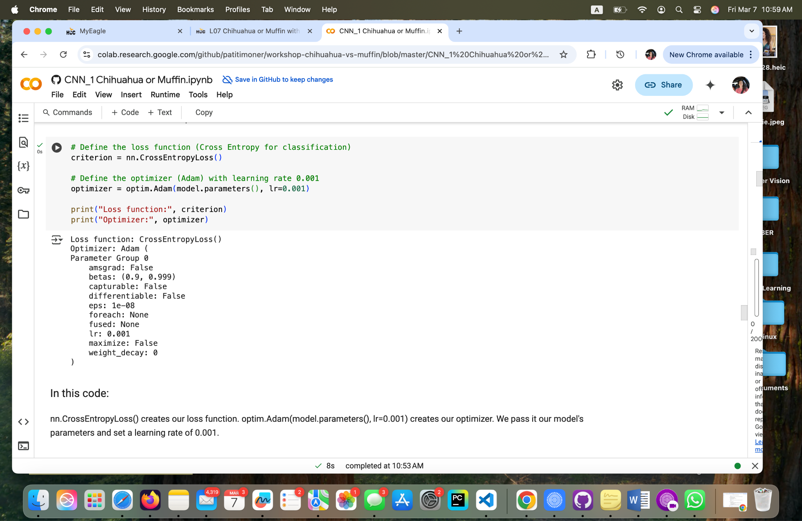

**Fig 8 - Yoana Cook: Classifying and optimizing the model.**

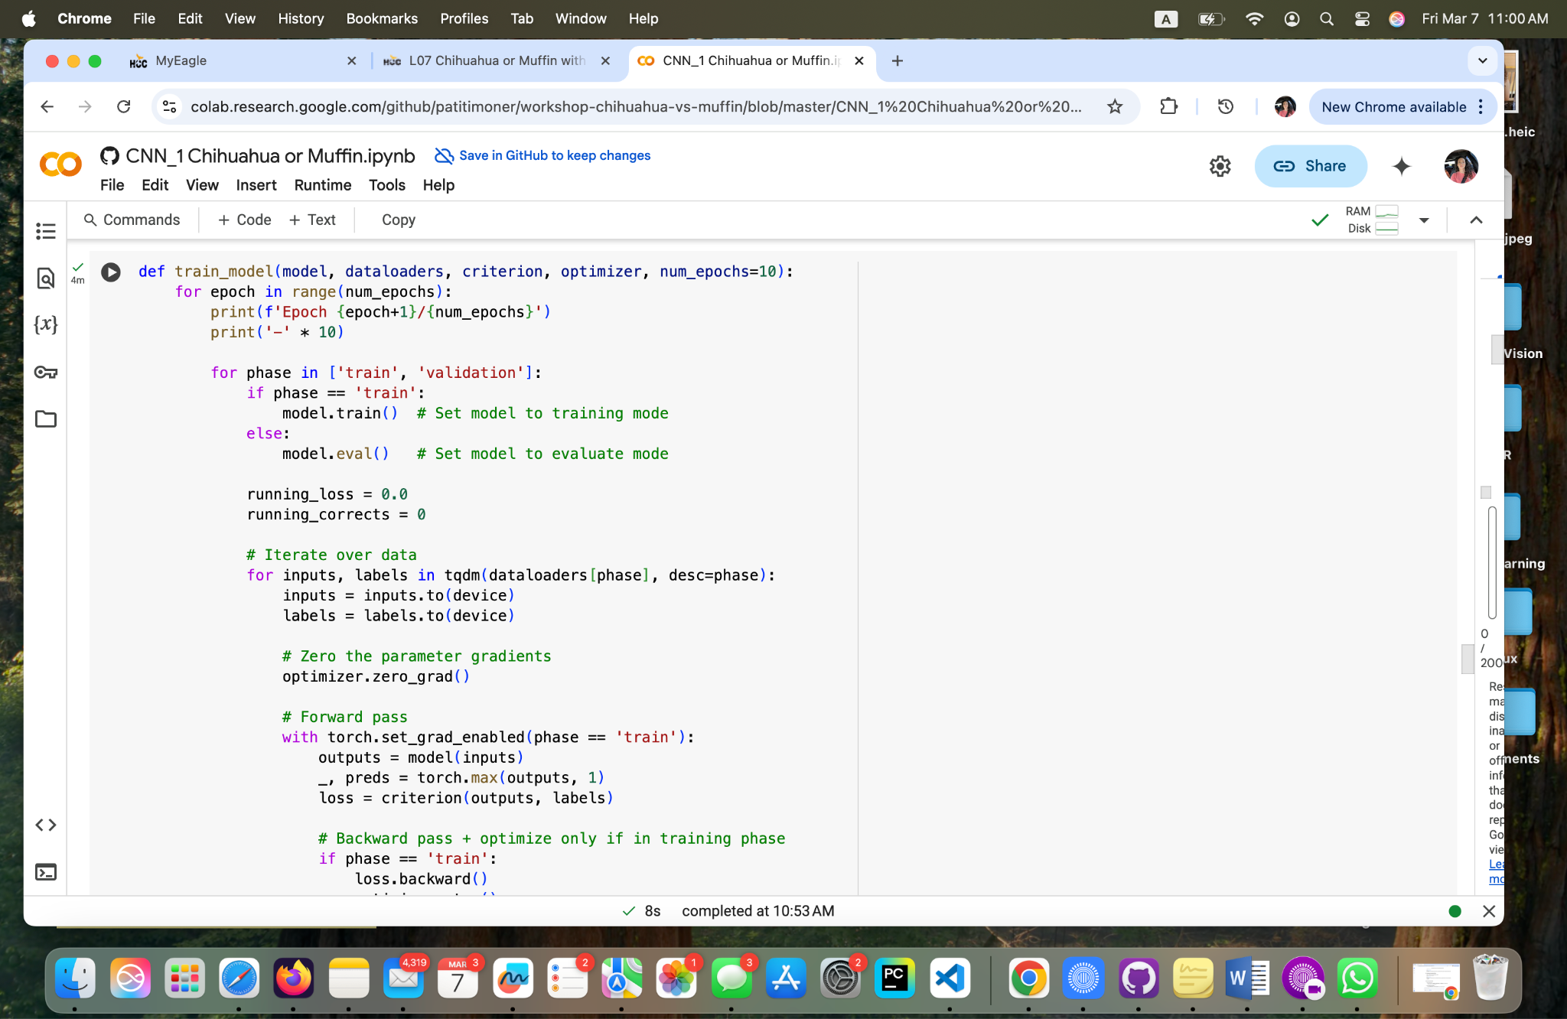

**Fig 9 - Yoana Cook: Model training.**

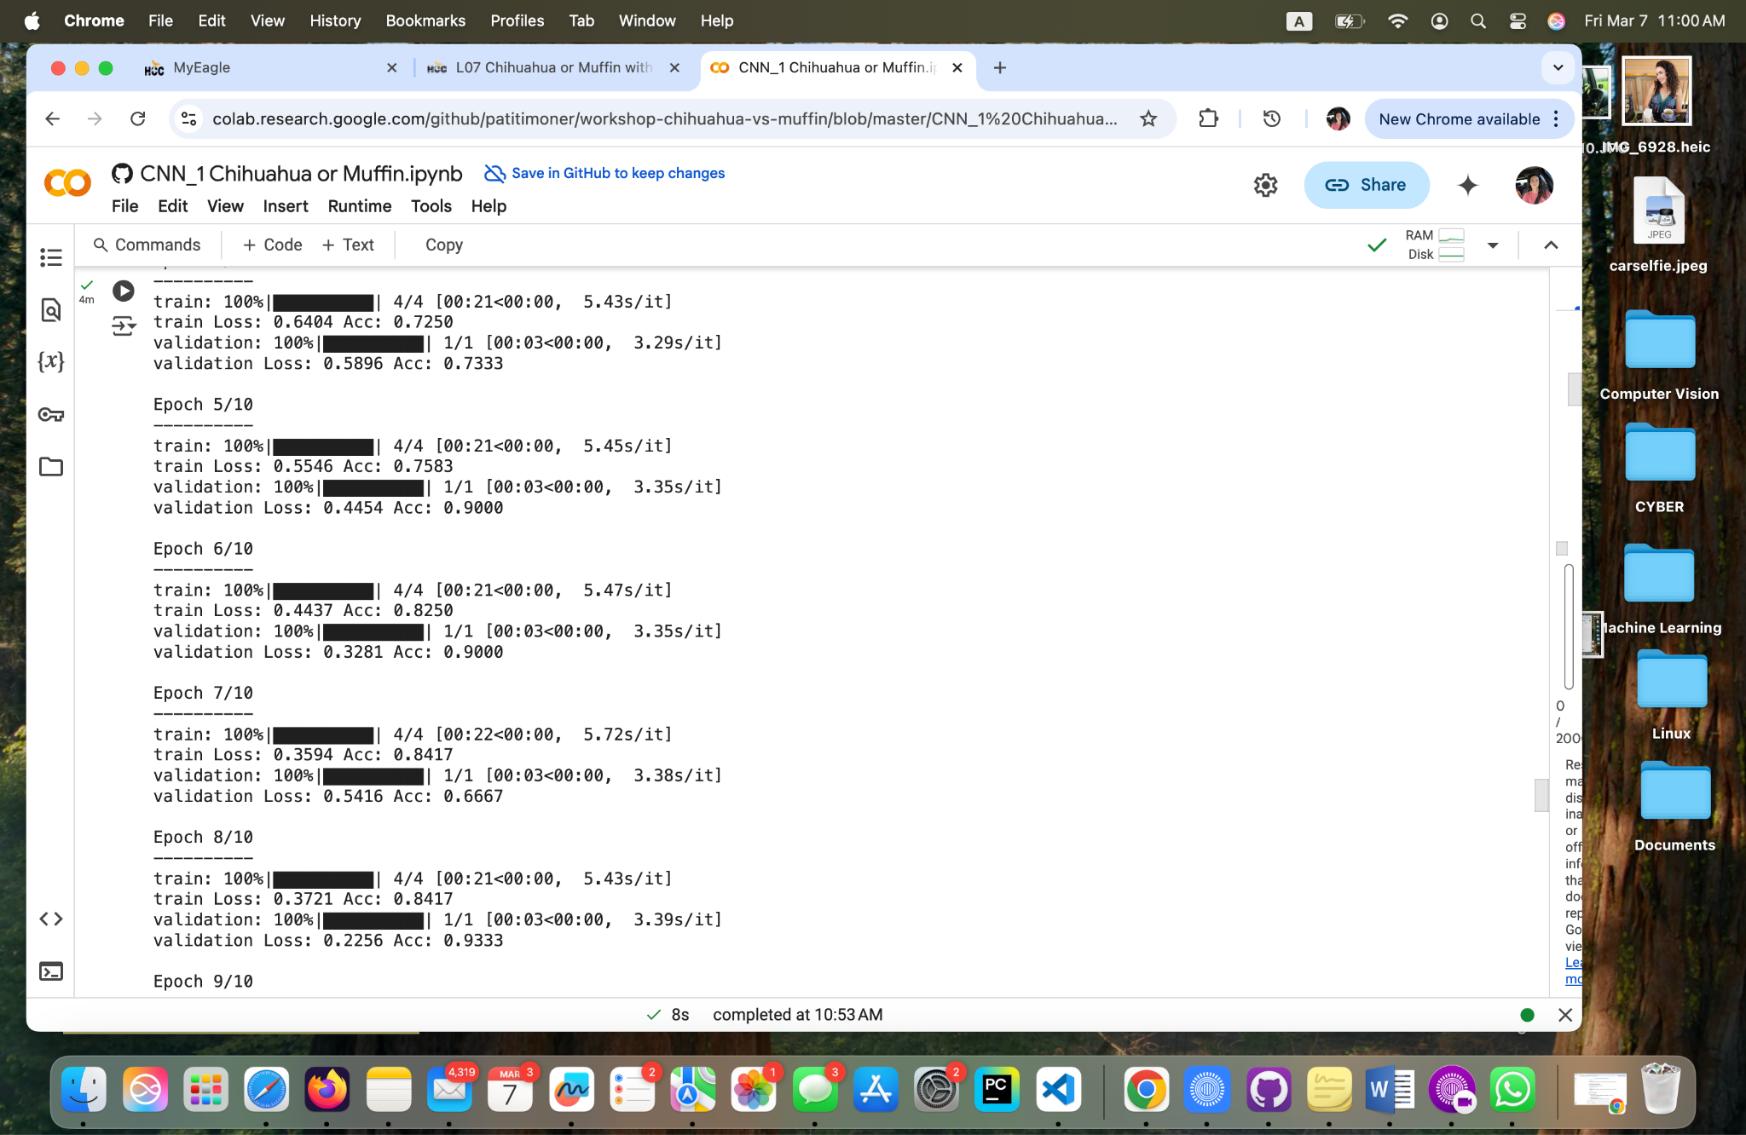

**Fig 10.1 - Yoana Cook: Model training.**

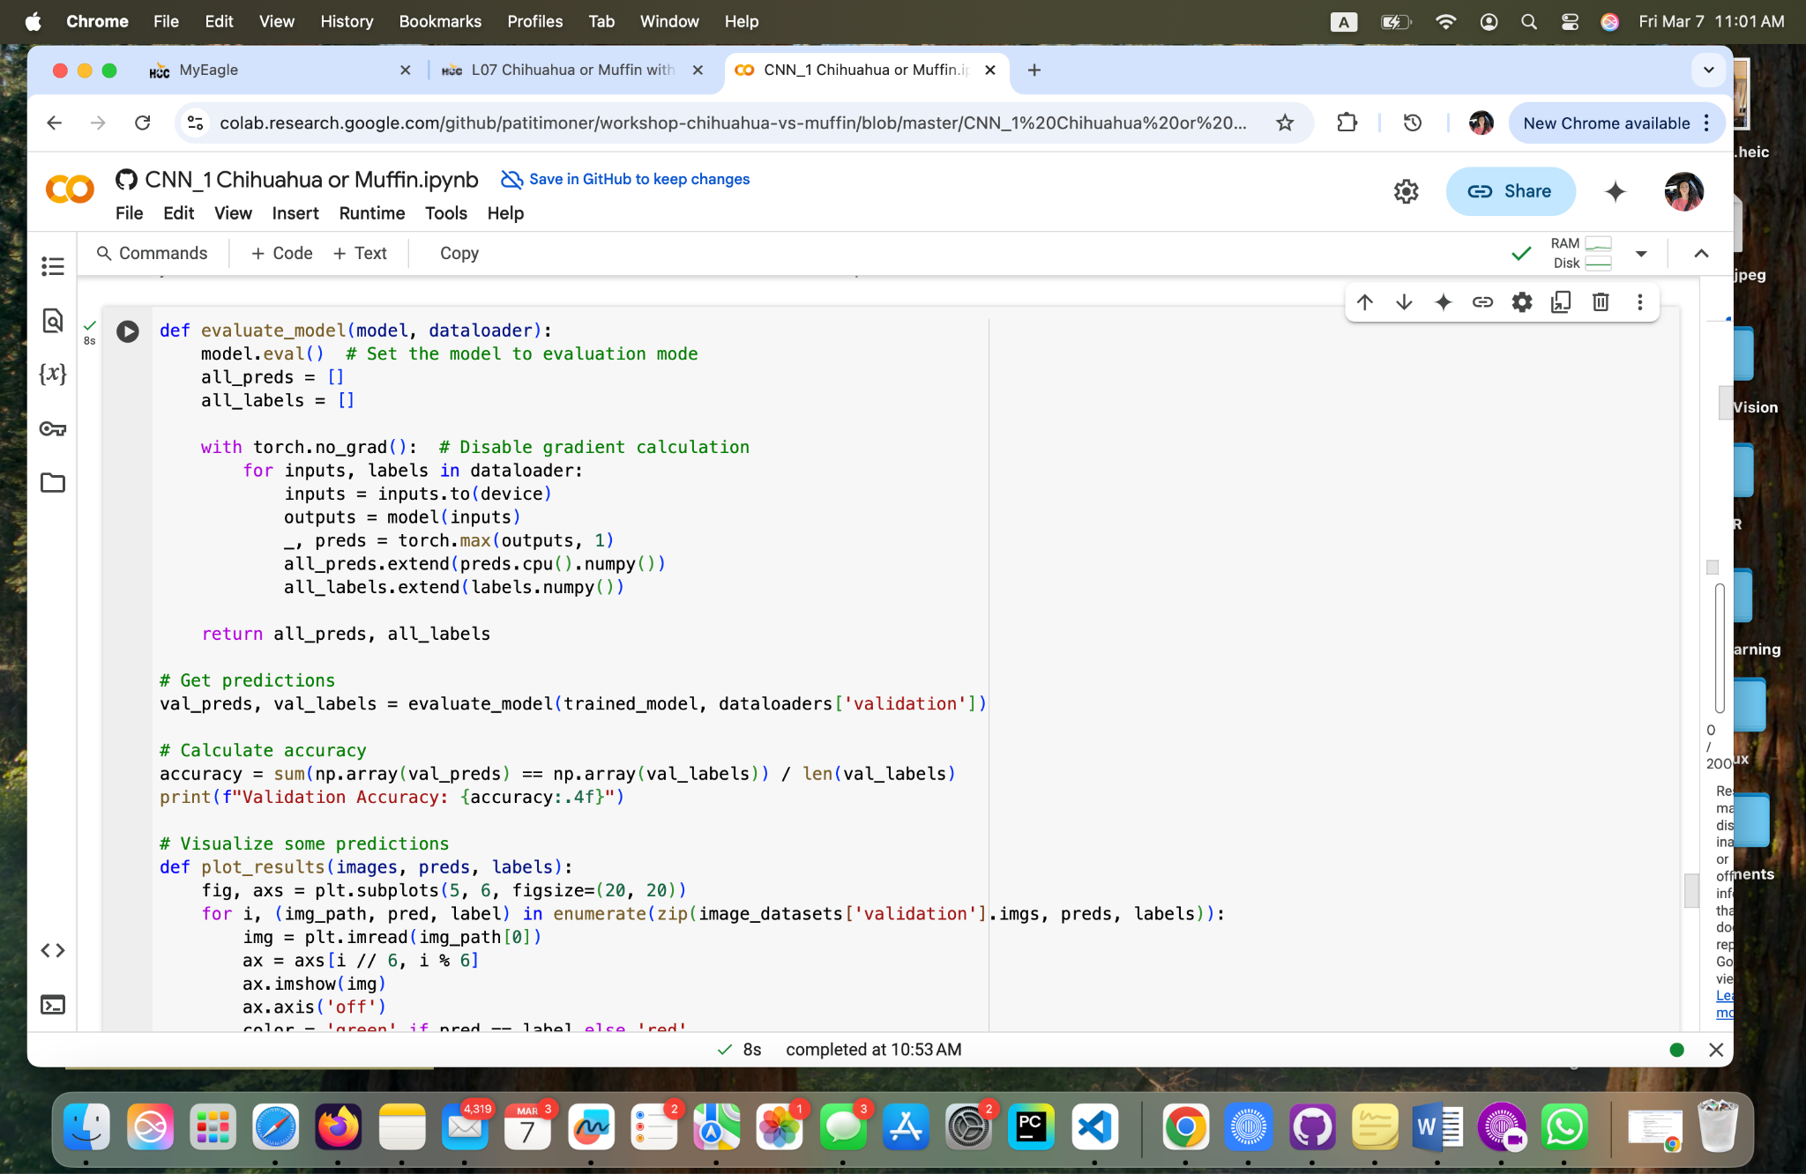

**Fig 11 - Yoana Cook: Evaluating the model performance.**

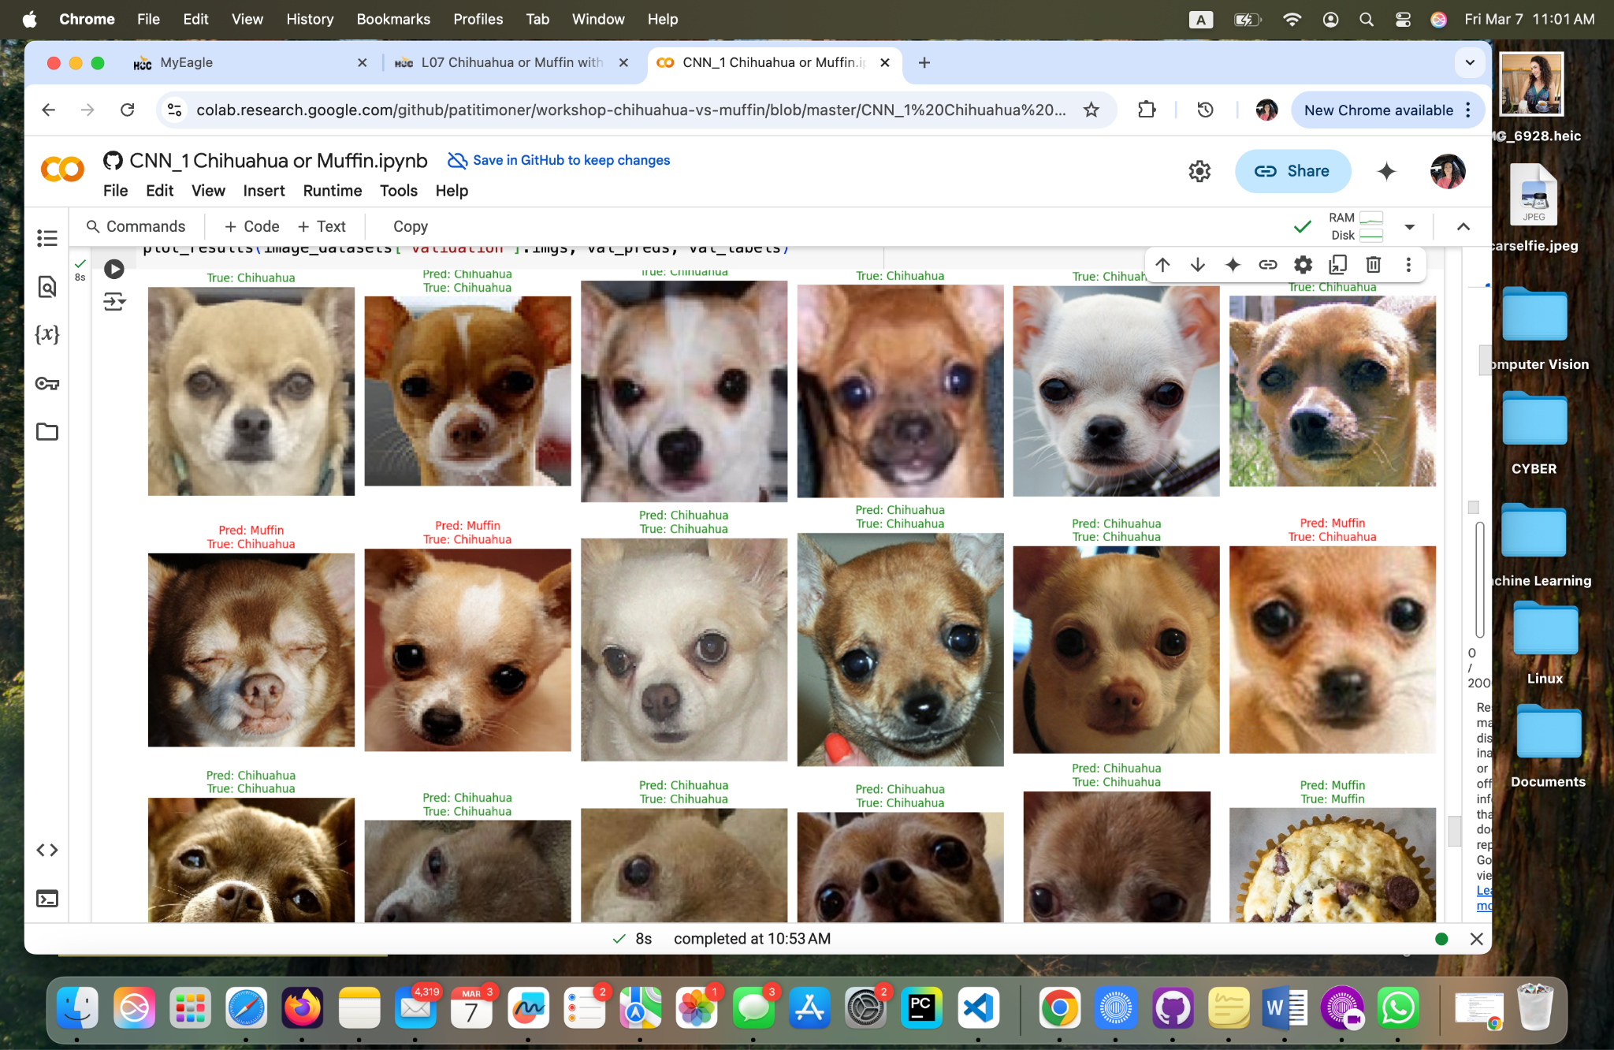

**Fig 12 - Yoana Cook: Validation.**

**Personal Reflection**

**How does the performance of this CNN compare to the traditional Neural Network from the previous workshop?**

* **Comparison: CNNs typically outperform traditional fully connected neural networks (FNNs) in image classification due to their ability to capture spatial hierarchies and local patterns.**
* **Reasoning: Traditional neural networks treat images as flat vectors, losing spatial structure. CNNs use convolutional layers to extract meaningful features such as edges, textures, and shapes.**
* **Empirical Evidence: If you have accuracy or loss metrics from both models, compare them to demonstrate CNN's superiority in terms of accuracy and efficiency.**

**What role do the convolutional layers play in image classification?**

* **Convolutional layers act as feature extractors, detecting patterns like edges, corners, and textures in early layers, then more complex structures in deeper layers.**
* **These layers reduce dimensionality while preserving important spatial relationships, making CNNs robust to variations in input images.**
* **They enable parameter sharing, meaning fewer parameters compared to fully connected networks, reducing computational costs.**

**How might you further improve this model's performance?**

* **Data Augmentation: Increase dataset diversity by applying transformations like flips, rotations, and brightness adjustments.**
* **Fine-Tuning & Transfer Learning: Use a pre-trained CNN (e.g., ResNet, EfficientNet) and fine-tune it for your dataset.**
* **Hyperparameter Tuning: Optimize learning rate, batch size, dropout rate, and number of filters.**
* **Regularization: Use dropout or L2 regularization to prevent overfitting.**
* **Ensemble Methods: Combine predictions from multiple models for better generalization.**

**What challenges might this model face in real-world applications?**

* **Generalization Issues: CNNs might perform well on training data but fail on unseen, real-world images with different lighting, angles, or noise.**
* **Computational Cost: High resource demand, especially for large-scale applications, requiring GPUs/TPUs.**
* **Adversarial Attacks: Small, imperceptible perturbations in input images can mislead CNNs.**
* **Bias in Training Data: If the dataset lacks diversity, the model may exhibit biased behavior, leading to unfair or inaccurate classifications.**
* **Data Privacy: Some applications require user-sensitive images, raising privacy concerns.**

**How does data augmentation (like random flips and rotations) contribute to the model's performance?**

* **Improves Generalization: Helps the model learn invariant features by exposing it to different versions of the same data.**
* **Reduces Overfitting: Prevents the model from memorizing specific features in training data by introducing variations.**
* **Expands Dataset Size: Artificially increases the training data, making the model more robust to real-world scenarios.**
* **Encourages Better Feature Learning: Forces the model to focus on essential patterns rather than relying on fixed orientations or backgrounds.**

**What are the ethical considerations in developing and deploying an image**

**classification system like this?**

* **Improves Generalization: Helps the model learn invariant features by exposing it to different versions of the same data.**
* **Reduces Overfitting: Prevents the model from memorizing specific features in training data by introducing variations.**
* **Expands Dataset Size: Artificially increases the training data, making the model more robust to real-world scenarios.**
* **Encourages Better Feature Learning: Forces the model to focus on essential patterns rather than relying on fixed orientations or backgrounds.**

**Matthew Choo**

* **After working on the CNN_1 Chihuahua or Muffin.ipynb, I have to use a specific type of code to clone the repository in google colab. I began running the code and it began to run smoothly until there was an error in fig 17. Have to change the code by doubling it (Fig 30). After finishing running the code, I was able to understand what the file is about. The code that was given was using the CNN where it is used to run the results of images of both chihuahuas and muffins. Overall this was an interesting file using CNN.**

**Cameroun White**

* **In order to work on this assignment, I needed to use a certain code to clone the repository in Google Colab. I started running the code, and it ran perfectly until an error was prompted. I then had to modify the code by doubling it to fix the issue. After finalizing the execution, I was able to understand the purpose of the file. The code given, utilized a CNN to analyze and classify images of both Chihuahuas and muffins. Completing this assignment was more insightful and amazing to see a different approach to predicting the outcome for comparisons between muffin and Chihuahua.**

**Melvis Maduagwu**

* **In this Lab, We used a (CNN) Convolutional Neural Network to Classify images of Chihuahuas and muffins. Last time, we used a regular Neural Network to perform this task. Although we followed the same procedures of Building the Network, loading the data, training the model on the data and examining its output, I must say the results were 1 more accurate this time around. I believe the results came out better this time because convolutional neural networks are more suitable for image classification due to the fact that it is inspired by the human visual cortex. This allows the network to extract relevant features from pixel data.**

**Erick Banegas**

**NancyChieu**

* **In L06, I did Image Classification between Chihuahua and Muffin using the regular neural networks (NNs). The regular NN is the basic machine learning with each neuron of the first layer connected to each neuron of the next layer. All neurons are fully connected. In Convolutional Neural Networks (CNNs), it uses convolutional layers with filters/kernels to detect spatial patterns, followed by pooling layers to reduce dimensionality, and fully connected layers for classification. In L06 with the regular NNs, it was much more time consuming to do the Image Classification than L07 with CNNs. With the regular NNs for L06 I also ran into more errors and took a long time to figure out how to correct the errors. In L07 with CNNs, I only encountered one error and was able to fix it much easier than L06.**

**Yoana Cook**

* The "Chihuahua or Muffin" repository is a practical introduction to image classification using Convolutional Neural Networks (CNNs). It is a great example of how machine learning can tackle even quirky problems while teaching important concepts. The project focuses on distinguishing between images of Chihuahuas and muffins, two things that look surprisingly alike - using a CNN model.

The task of telling apart Chihuahuas and muffins highlights how subtle visual differences can be, making it a great way to learn about feature extraction and pattern recognition in images.

The repository covers key steps like resizing images, normalizing pixel values, and splitting data into training and testing sets. These are essential skills for any image classification task, whether one is working on something fun like this or more serious applications like medical imaging.

While the problem is playful, the techniques used here, such as CNNs and data augmentation are widely used in real-world applications, from self-driving cars to facial recognition. This makes the project a great starting point for learning skills that apply to more complex tasks.

This project is a fantastic way to get hands-on with deep learning. It is approachable, engaging, and teaches us the basics of CNNs in a way that is easy to understand. Additionally, it is a great reminder that machine learning does not always have to be serious - it can be fun, too!

**GitHub Link**

**Matthew Choo**

<https://github.com/MattChoo0/CNN_1-Chihuahua-or-Muffin>

**Cameroun White**

[**https://github.com/OhMyGodCam/workshop_ipynb.git**](https://github.com/OhMyGodCam/workshop_ipynb.git)

**Melvis Maduagwu**

[**https://github.com/Melvis-07/workshop-chihuahua-vs-muffin**](https://github.com/Melvis-07/workshop-chihuahua-vs-muffin)

**Erick Banegas**

**NancyChieu**

<https://github.com/nchieu2025/https://github.com/nchieu2025/jupyter-exploration/>

CNN_1-Chihuahua-or-Muffin

**Yoana Cook**

[**https://github.com/YoanaKC/The-eagles/blob/main/CNN_1%20Chihuahua%20or%20Muffin.ipynb**](https://github.com/YoanaKC/The-eagles/blob/main/CNN_1%20Chihuahua%20or%20Muffin.ipynb)

Bibliography

“Understanding Deep Convolutional Neural Networks.” Understanding,

[www.run.ai/guides/deep-learning-for-computer-vision/deep-convolutional-neural-networks#:~:te](http://www.run.ai/guides/deep-learning-for-computer-vision/deep-convolutional-neural-networks#:~:te)

xt=The%20network%20employs%20a%20special,%2C%20activation%2C%20and%20fully%20

connected. Accessed 2 Mar. 2025.

“What Is a Convolutional Neural Network?: 3 Things You Need to Know.” What Is a

Convolutional Neural Network? | 3 Things You Need to Know - MATLAB & Simulink,

www.mathworks.com/discovery/convolutional-neural-network.html. Accessed 1 Mar. 2025.